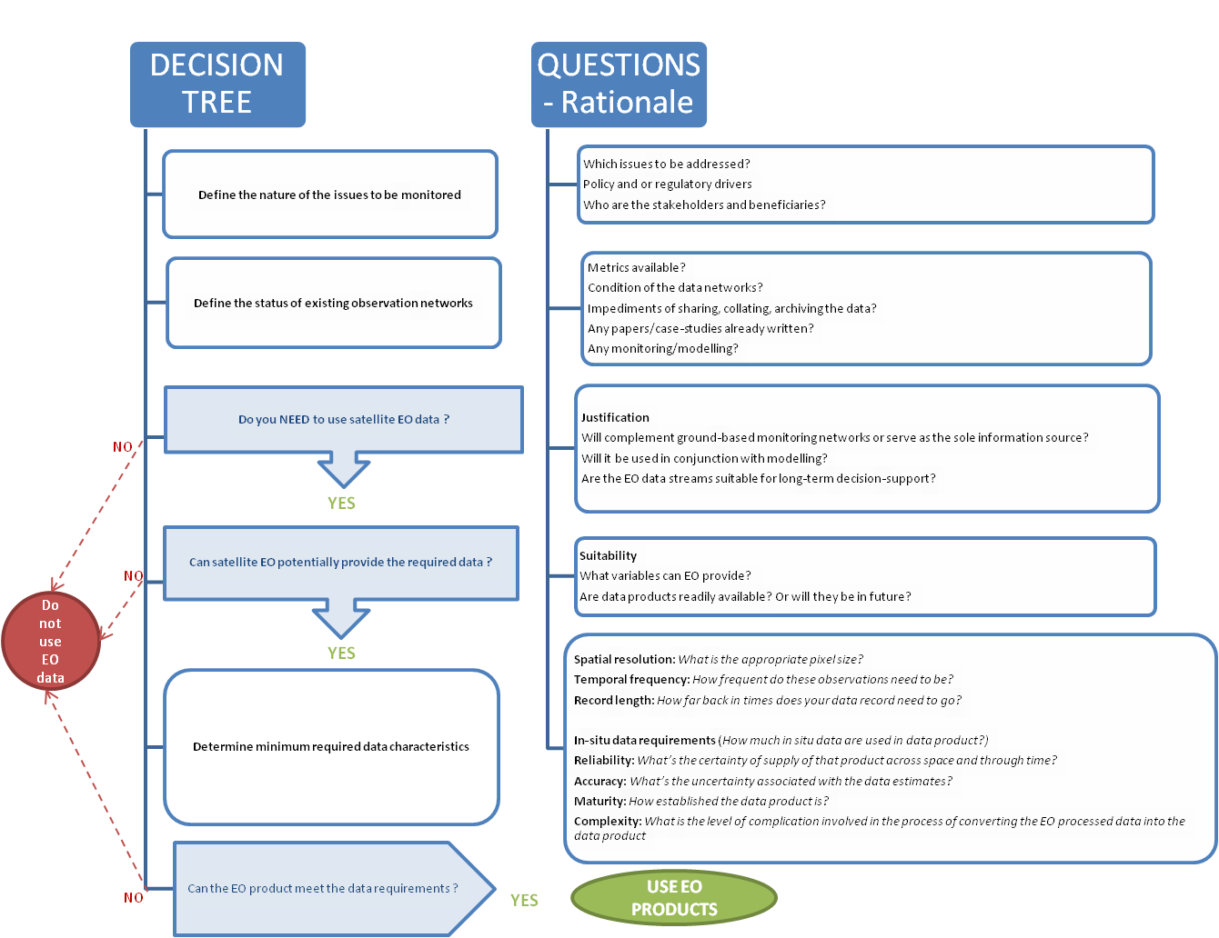
- From: Siu. M-T (editor) Dr Hannes I. Reuter (Eurostat), Dr Arnold Dekker, Flora Kerblat, Dr Alex Held and Dr Robert Woodcock (Commonwealth Science and Industrial Research Organisation) Alexis McIntyre (Geoscience Australia), Professor Kerrie Mengersen and James McBroom (Queensland University of Technology), Sandra Yaneth Rodriquez (Departamento Administrativo Nacional de Estadistica), and Jacinta Holloway (Australian Bureau of Statistics). I would also like to thank the authors of the Task Team Pilot reports, Patrick Dunagan (Google), Ronaldo Ocampo and José De La Torre (Instituto Nacional de Estadística Geografíca e Informática), Jennifer Marley, Ryan Defina, Kate Traeger, Daniel Elazar, Anura Amarasinghe and Gareth Biggs (Australian Bureau of Statistics). (2017) Earth Observations for Official Statistics Satellite Imagery and Geospatial Data Task Team report 5 th December 2017 White cover publication, United Nations Australian Bureau of Statistics Queensland University of Technology, Australia Queensland Government, Australia Commonwealth Scientific and Industrial Research Organisation, Australia European Commission – DG Eurostat National Institute of Statistics and Geography, Mexico Statistics Canada.
When determining whether EO data is appropriate for specific statistical purposes, a key question is whether the required data or information products can be generated from EO at all. The decision-tree in Figure 1 will help to decide whether it is appropriate and possible to use EO data products.
Figure 1: CSIRO Decision Tree on usage of EO data for NSOs
Case studies of implementation of EO data for statistical purposes would be useful in order to further assist with making decisions for the business case about methodological feasibility and costs of acquiring, preparing and pre-processing this data. Such case studies could then help inform decisions for future applications.

5.4.1 Minimum data requirements for EO
To determine minimum EO data requirements, the following questions need to be raised and answered before deciding to use EO data:
Justification |  | Do you need to use EO? Is there a better alternative source?
Suitability |  | Can EO provide the required data products?
Spatial resolution |  | What is the appropriate size of pixel?
Temporal frequency |  | What is the required frequency of these EO data acquisitions?
Record length |  | How far back in time does your data record need to go?
Reliability | Do you need guaranteed continuation of data supply into the future?
Accuracy | What degree of accuracy is needed in the information product?
Maturity | Do you want to use only information products that are well documented and are commonly used?
Complexity | What data management, processing and analysis capacity is available?
Figure 2: Requirements for the use of EO (after WorldBank 2016 page 7 Executive Summary)

WorldBank Report: L.E. García, D. J. Rodríguez, M. Wijnen and I Pakulski (Eds.), ‘Earth Observation for Water Resources Management: Current Use and Future Opportunities for the Water Sector’, (2016) The World Bank Group, Washington, USA, pp 145-166. ISBN: 978-1-4648-0475-5; e-ISBN: 978-1-4648-0476-2; http://dx.doi.org/10.1596/978-1-4648-0475-5

