Questions to address when considering the use of RS for water-related issues:
- Nature of the WRM problem
  - What WRM questions need to be answered?
  - What are the policy and or regulatory drivers of these questions?
  - Who are the stakeholders and beneficiaries of a solution to the WRM problem?
- Existing data and observation networks
  - What metering is currently available?
  - What is the condition of the data networks?
  - Are there any impediments to sharing, collating, archiving the data (e.g., transboundary issues)?
  - What, if anything, has been done in the past to address the issues at hand?
    - Any monitoring? Modelling?
  - Can EO fill an information gap?
    - Will EO complement field monitoring networks or serve as the sole information source?
    - Will EO be used in conjunction with modelling?
    - Are the EO data stream(s) suitable for long-term WRM decision support?
- Sustaining and maintaining WRM decision support and monitoring programs
  - Is there capability to adopt a solution in the short and longer term?
  - What are the key organizations nationally, and who the international experts, to partner with around EO?
  - What is the local capability to adopt new techniques and technologies?
    - What computing infrastructure, if any, is needed? Is it available, and who owns it?
    - To what degree will local expertise require training in new techniques and technologies?
  - What level of national versus international resourcing will be required?
The information needed and relevant questions to ask (see the box above) are summarized in the flowchart on the next page. In addition, examples are given to illustrate how the underlying decision-making process might proceed in practice.
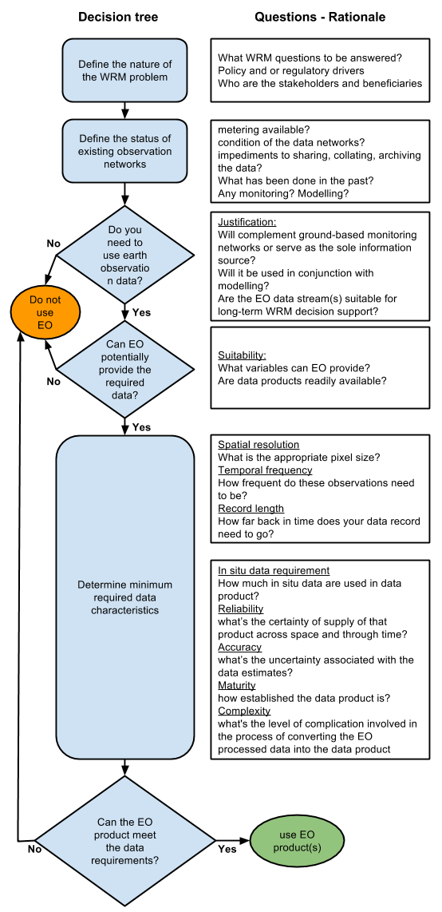

WRM problem to be solved;
Relevant stakeholders

Conditions of data network, data-sharing possibility, existing monitoring and models, etc.

Justification

EO suitability

Spatial resolution

Temporal resolution (revisit frequency)

Record length

In-situ data requirements

Reliability

Accuracy

Maturity

Complexity

The table presented on the next page illustrates a hypothetical case involving a water-quality problem in a large lake in a subtropical environment.
Guiding questions | Characteristic
Do you need to use EO data? | Justification | If there is no other source of information on water quality going back at least 10 years, yes. Information from EO data is needed, as it is the only archival information of a (semi-)quantitative nature available
Can EO provide the required data products? | Suitability | Yes, retrospective information on chlorophyll, cyanophycocyanin, suspended matter, turbidity, Secchi Disk transparency, and vertical attenuation coefficient of light is key information through time and space to better understand what aquatic ecosystem processes occurred in the last 10 years. However, each satellite sensor will differ in terms of ability to differentiate water-quality variables, depending on its spectral resolution (see Table II-15).
What is the appropriate pixel size? | Spatial resolution | Given that the lake measures 40 x 8 km, lies in the subtropics (with a wet, cloudy season in which the lake is often obscured, and a dry season with clear-sky conditions), and that the period of interest is at minimum the last 10 years, a study of tables II-1, II-2, and Table II-15 shows that the MODIS, MERIS, and Landsat sensor image data are the appropriate ones to use.
How frequently do these observations need to be? | Temporal resolution | Coarser-scale MODIS and MERIS data offer a higher revisit frequency of coverage. However, under cloud-free conditions, Landsat may offer sufficient frequency.
How far back in time does your data record need to go? | Record length | The length of the archive available and the period of interest will determine the suitability of each satellite sensor.
Do you need guaranteed continuation of data supply into the future? | Reliability | Use Tables II-1, Table II-2, and Table II-15 to identify the sensor systems with continuing future data supply.
What degree of accuracy is needed in the data products? | Accuracy | The capability to measure all water-quality variables in Table II-15 increases from Landsat to MODIS to MERIS on the basis of their spectral characteristics. The accuracy will generally be highest for MERIS.
Do you want to use only data products that are commonly used? | Maturity | EO algorithms for water-quality products are summarized in Table II-25,  Table II-26, and Table II-27. Progressing from empirical methods (requiring a sufficient number of simultaneous field measurements synchronous with a satellite overpass) to semi-empirical measurements, to semi-analytical methods, the reliability and accuracy increase, but the complexity also increases while the maturity decreases. The crucial relevant question for this specific case study is: Do you need qualitative assessment of change or do you need the most reliable concentration estimates?  In this case, a qualitative assessment of the satellite archive—allowing for the mapping of the transition in time and space from a mesotrophic, clear lake, to a hypertrophic, algal bloom-dominated lake over a span of about 10 years—does not require accurate, water-quality retrievals but does require frequent images that make it possible to see when cyanobacteria start dominating the system. This leads to the conclusion that preference should be given to the MERIS archive, using off-the-shelf products available through the BEAM software package.

From: page 7 Executive Summary In L.E. García, D. J. Rodríguez, M. Wijnen and I Pakulski (Eds.), ‘Earth Observation for Water Resources Management: Current Use and Future Opportunities for the Water Sector’, The World Bank Group, Washington, USA, pp 145-166. ISBN: 978-1-4648-0475-5 Authored by: Guerschman Juan P. (CSIRO), Donohue, Randall J. (CSIRO), Van Niel Tom G. (CSIRO), Renzullo Luigi J. (CSIRO), Dekker Arnold G. (CSIRO), Malthus Tim J. (CSIRO), McVicar Tim R. (CSIRO) and Van Dijk, Albert I. J. M. (CSIRO and Australian National University)

