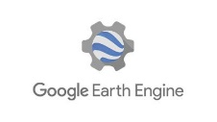
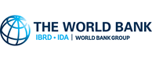
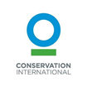
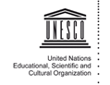
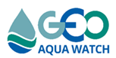

Development of Global Water Quality Geospatial Products and Tools
A collaborative project between GEO AquaWatch, the World Bank, Conservation International, UNESCO and Google Earth Engine
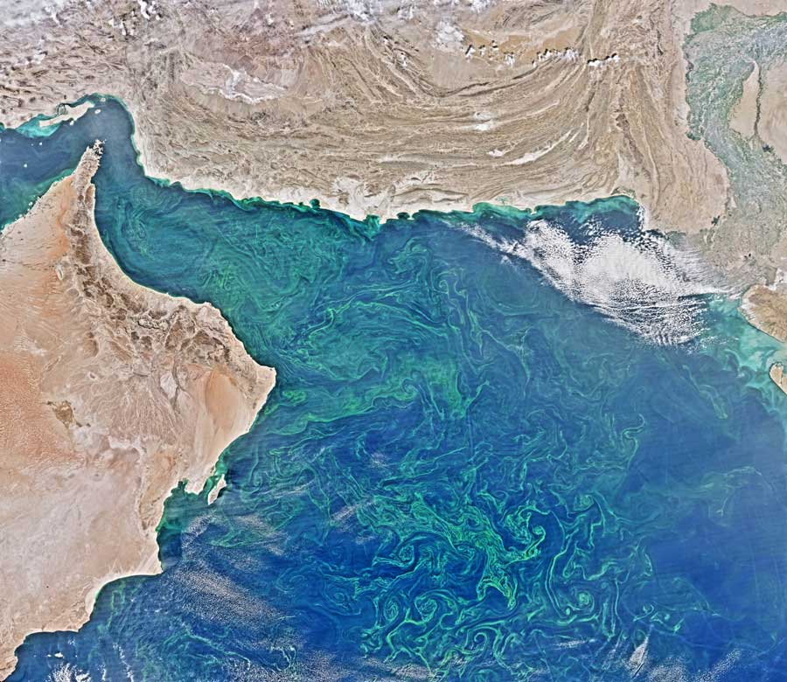
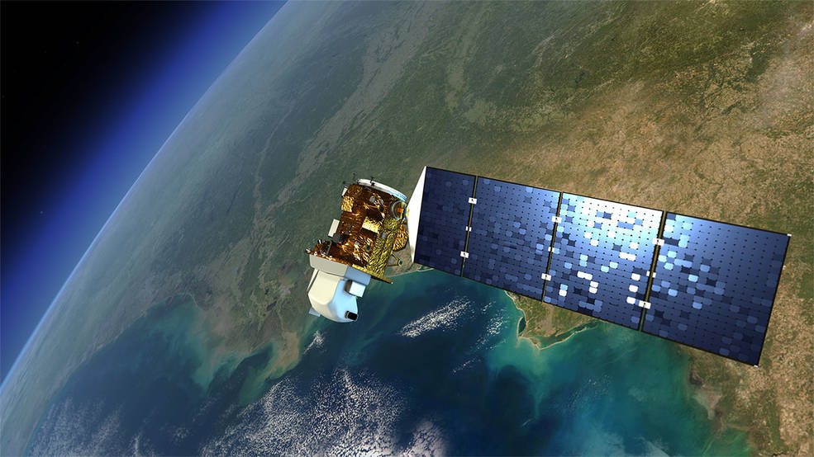
Water quality is critical for both human and ecosystem health and is affected by a wide range of natural and anthropogenic influences. The assessment and monitoring of global coasts, lakes and rivers are crucial to our ability to understand the effects of environmental change on aquatic ecosystems and to model future change. However, given the large span of surface water (e.g. 117 million lakes) and with limited resources, water quality monitoring is quite challenging, if simply non-existent. Recent advances in satellite remote sensing, both in terms of sensor capabilities and associated algorithmic approaches now provide the opportunity to monitor essential surface water quality conditions from space. This new, transformative approach to water quality monitoring can elucidate inland and coastal conditions in near-real time.
Illustration of Landsat satellite
Credits: NASA's Goddard Space Flight Center

Project Goal The goal of this project is to provide a global-scale, open access, freely available fit-for-purpose weekly chlorophyll-a, total suspended solids and colored dissolved organic matter (CDOM) water quality information for inland and coastal waters to be used by multiple end users including the science community, water resource managers, industry and the general public. This proposal seeks to complete this work through a collaborative effort between the GEO AquaWatch community, the World Bank, Conservation International and Google Earth Engine, leveraging their respective strengths.
Arabian Sea near the coasts of Oman, Iran, and Pakistan. (Credits: N. Kuring/NASA Ocean Color Web)

Project objectives
a.) Obtain scientific community consensus for an operational system design for satellite remote sensing of surface water quality addressing both atmospheric correction and water quality algorithms
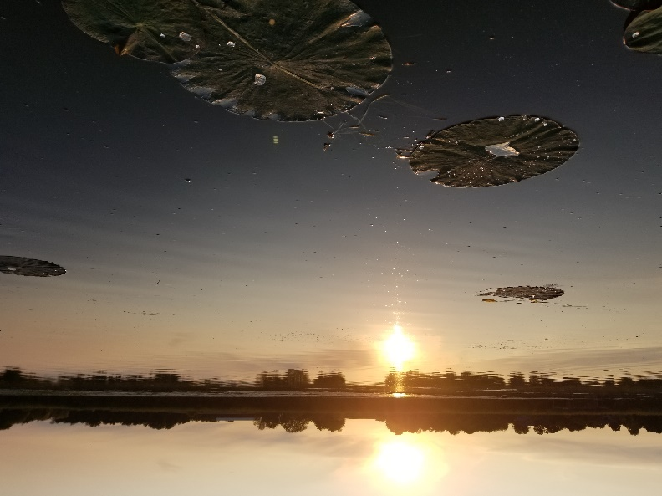
b.) Construct a near real time (within constraints of data streams), interactive portal of surface water quality with global coverage.
Yahara River, WI. Credits: S. Greb/U. Wisconsin
c.) Leverage existing Conservation International, World Bank, UNESCO and AquaWatch projects and engage local water resource managers and citizen scientists in testing, validation and providing feedback on suggested improvements (co-design).
d.) Promote this tool through the Group on Earth Observation (GEO) community and GEOSS portal, AquaWatch, the World Bank and Conservation International.

For further information about this project, contact Steve Greb, GEO AquaWatch Director srgreb@wisc.edu
For further information about GEO AquaWatch, contact Merrie Beth Neely or our website https://www.geoaquawatch.org/

