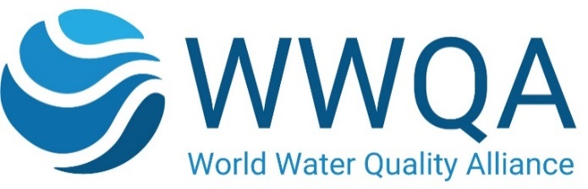

Proposal Template for WWQA Workstreams

General Information
Proposal Summary:
For proposals within existing WWQA Workstream/s: | Please indicate the workstream of the Alliance which your proposal primarily addresses. Indicate other related workstreams it relates to if applicable (see: https://wwqa.info/workstreams).  Explain how your proposal addresses the specific challenges and scope of that topic.  (Max. 200 words)
For new proposals outside existing WWQA Workstreams: | If your proposal is completely new and thus yet unrelated to the existing Alliance workstreams please explain how your activity has potential to lead into a new, broader workstream. Indicate other related workstreams it may relate to if applicable.  Explain the specific challenges and scope of the new topic.  (Max. 200 words)
Workstream Title:

Workstream Rationale/Summary: | Describe and explain the overall concept, the main ideas and assumptions involved. Identify any inter-disciplinary considerations and use of stakeholder incl. civil society or indigenous knowledge, as applicable. Include measures taken for public/societal engagement on issues related to the project.  Describe any other of your projects and/or activities that are linked to this workstream, especially where the outputs from these will feed into broader Alliance principles ;  (Max. 700 words)
Objectives: | Describe the main objectives  (Max. 500 words)
Outputs, Deliverables and Milestones: | Describe outputs and milestones in bullets in the course of Jan- Dec 2024  (Max.250 words)
Impacts and outcomes: | • Summarize the anticipated mid to long-term impacts and outcomes of your workstream, and its contribution to the objectives and principles of the World Water Quality Alliance and the World Water Quality Assessment (as applicable)  - Explain what expected impacts and outcomes are anticipated e.g., create new opportunities; bring important benefits for water management; how your proposal incorporates and can contribute/pay attention to interlinkages and cross-cutting issues like climate change impacts, protection or restoring ecosystems, but also gender, youth, indigenous peoples, SME farmers, local communities and business etc.  (Max.500 words)
Risk factors concerning implementation: | - Describe any barriers/obstacles, such as regulations, public acceptance, financing of follow-up steps, etc., that may determine whether the expected impacts and outcomes will be achieved.  - Describe the risks concerning implementation and if possible, indicate level of likelihood: Low/Medium/High  - For each risk identified, propose risk-mitigation measures  (Max.500 words)
Regions & Countries of Operation:

Resources the WWQA can leverage from the workstream
Amount requested from WWQA seed-funds as co-financing (US$) – if applicable

Workstream Leader and Partners
Workstream Leader and Partners
Name and acronym of the proposed entity acting as workstream leader
Contact details of the individual representing the workstream leader
HQ country & address:
Type of Organization: | e.g., Not-for-Profit; NGO/ CSO; Government entity, UN Agency, etc.
Other Partners included in the workstream (all participating organizations, name and type of organization): | List the names of other key partners contributing to the workflow, including a brief description of their role.
Key references regarding the qualification/experience of the main coordinator and/or the partners for implementing the suggested workstream.

